Assignment no -9

Title - Trip History Analysis : Use trip history dataset that is from a bike sharing service in the United States. The data is provided quarter -wise from 2010 (Q4) onwards. Each file has 7
Columns. Predict the class of user.
Theory -
System Data
Where do Capital Bikeshare riders go? When do they ride? How far do they go? Which stations are most popular? What days of the week are most rides taken on? We've heard all of these questions since we launched in 2010, and we're glad to provide the data that shows you the answers from our first trip to today.
We invite developers, engineers, statisticians, artists, academics and other interested members of the public to use the data we provide for analysis, development, visualization or whatever else moves you.
This data is provided according to the Capital Bikeshare Data License Agreement.
Trip History Data
Each quarter of Capital Bikeshare trip data. The data includes:
- Duration – Duration of trip
- Start Date – Includes start date and time
- End Date – Includes end date and time
- Start Station – Includes starting station name and number
- End Station – Includes ending station name and number
- Bike Number – Includes ID number of bike used for the trip
- Member Type – Indicates whether user was a "registered" member (Annual Member, 30-Day Member or Day Key Member) or a "casual" rider (Single Trip, 24-Hour Pass, 3-Day Pass or 5-Day Pass)
This data has been processed to remove trips that are taken by staff as they service and inspect the system, trips that are taken to/from any of our “test” stations at our warehouses and any trips lasting less than 60 seconds (potentially false starts or users trying to re-dock a bike to ensure it's secure).
Classification
Classification can be performed on structured or unstructured data. Classification is a technique where we categorize data into a given number of classes. The main goal of a classification problem is to identify the category/class to which a new data will fall under.

- Classifier: An algorithm that maps the input data to a specific category.
- Classification model: A classification model tries to draw some conclusion from the input values given for training. It will predict the class labels/categories for the new data.
- Feature: A feature is an individual measurable property of a phenomenon being observed.
- Binary Classification: Classification task with two possible outcomes. Eg: Gender classification (Male / Female)
- Multi class classification: Classification with more than two classes. In multi class classification each sample is assigned to one and only one target label. Eg: An animal can be cat or dog but not both at the same time
- Multi label classification: Classification task where each sample is mapped to a set of target labels (more than one class). Eg: A news article can be about sports, a person, and location at the same time.
The following are the steps involved in building a classification model:
- Initialize the classifier to be used.
- Train the classifier: All classifiers in scikit-learn uses a fit(X, y) method to fit the model(training) for the given train data X and train label y.
- Predict the target: Given an unlabeled observation X, the predict(X) returns the predicted label y.
- Evaluate the classifier model

DT is a classification scheme which generates a tree and a set of rules, representing the model of different classes, from a given dataset.As per Hans and Kamber [HK01], DT is a flow chart like tree structure, where each internal node denotes a test on an attribute, each branch represents an outcome of the test and leaf nodes represent the classes or class distributions. The top most node in a tree is the root node.

Figure 1 refers to DT induced for dataset in Table-
1. We can easily derive the rules corresponding to the tree
by traversing each leaf of the tree starting from the node.
It may be noted that many different leaves of the tree may refer to the same class labels, but each leaf refers to a different rule. DTs are attractive in DM as they represent rules which can readily be expressed in natural language. The major strength of the DT methods are the following:
1.DT are able to generate understandable rules.
2.They are able to handle both numerical and categorical attributes.
3.They provide a clear indication of which fields are most important for prediction or classification.

ID3 Algorithms-
Many DT induction algorithms have been developed in the past over the years. These algorithms more or less follow the basic principle discussed above. Discussion of all these algorithms is beyond the scope of the present chapter. Quinlan [Qui93] introduced the Iterative Dichotomizer 3 (ID3) for constructing the decision tree from data. In ID3, each node corresponds to a splitting attribute and each branch is a possible value of that attribute. At each node, the splitting attribute is selected to be the mostinformative among the attributes not yet considered in the path from the root. The algorithm uses the criterion of information gain to determine the goodness of a split. The attribute with the greatest information gain is taken as the splitting attribute,and the dataset is split for all distinct values of the attribute.
Description of the Data Set-

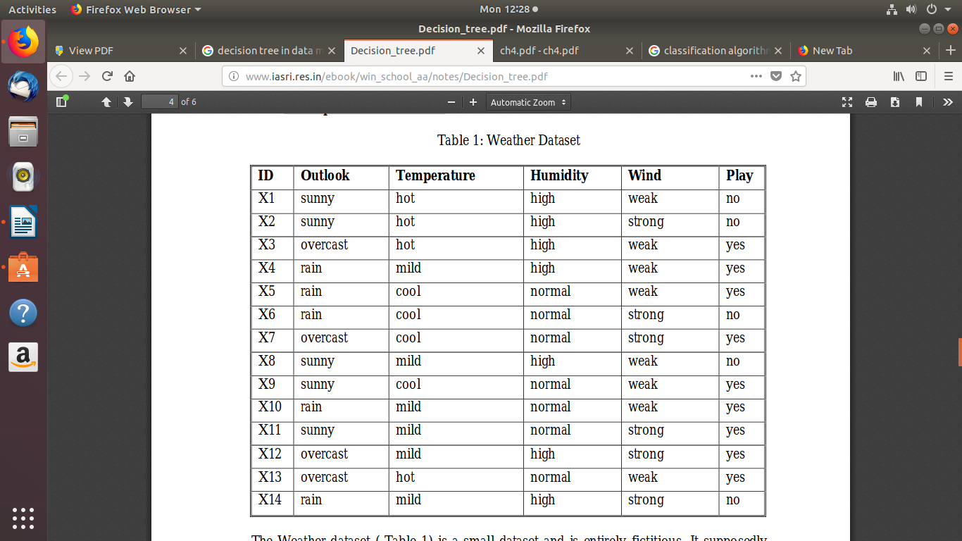
The Weather dataset ( Table 1) is a small dataset and is entirely fictitious. It supposedly concerns the conditions that are suitable for playing some unspecified game. The condition attributes of the dataset are in{Outlook,Temperature,Humidity, Wind} and the decision attribute is Play to denote whether or not to play. In its simplest form, all four attributes have categorical values. Values of the attributes Outlook,Temperature, Humidity and Wind are in {sunny, overcast, rainy}, {hot, mild, cool}, {high, normal} and {weak, strong} respectively. The values of all the four attributes produce 3*3*2*2 = 36 possible combinations out of which 14 are present as input.

Example 1-
To induce DT using ID3 algorithm for Table 1, note that S is a collection of 14 examples with 9 yes and 5 no examples. Using equation (2), Entropy (S) = -(9/14)* log2(9/14) –(5/14)* log2(5/14) = 0.940There are 4 conditional attributes in this table. In order to find the attribute that can serve as the root node in the decision tree to be induced, the information gain is calculated corresponding to all the 4 attributes. For attribute Wind, there are 8 occurrences of Wind = weak and 6 occurrences of Wind= strong. For Wind = weak, 6 out of the 8 examples areyes and the remaining 2 are no. For Wind = strong, 3 out of the 6 examples are yes and the remaining 3 are no. Therefore, by using equation (3) Gain (S, Wind) = Entropy (S) -(8/14) * Entropy (Sweak) - (6/14) * Entropy (Sstrong)= 0.940 -(8/14) (0.811) -(6/14) * 1.0= 0.048
Entropy (Sweak) = -(6/8) * log2 (6/8) -2/8 * log2 (2/8) = 0.811
Entropy (Sstrong) = -(3/6) * log2 (3/6) -(3/6) * log2 (3/6) =1.0
Similarly Gain (S, Outlook) = 0.246 Gain (S,Temperature) = 0.029
Gain (S, Humidity) = 0. 151 Outlook has the highest gain, therefore it is used as the decision attribute in the root node. Since Outlook has three possible values, the root node has three branches (sunny, overcast, rain). The next question is “which of the remaining attributes should be tested at the branch node sunny ?”
Ssunny = {X1, X2, X8, X9, X11} i.e. there are 5 examples from Table 1 with Outlook = sunny. Thus using equation (3),
Gain (Ssunny, Humidity) = 0.970
Gain (Ssunny, Temperature) = 0.570
Gain (Ssunny, Wind) = 0.019

The above calculations show that the attribute Humidity shows the highest gain, therefore, it should be used as the next decision node for the branch sunny. This process is repeated until all data are classified perfectly or no attribute is left for the child nodes further down the tree. The final decision tree as obtained using ID3 is shown later in Figure 1.
The corresponding rules are:
1.If outlook=sunny and humidity=high then play=no
2.If outlook=sunny and humidity=normal then play=yes
3.If outlook=overcast then play=yes
4.If outlook=overcast and wind=weak then play=yes
5.If outlook=overcast and wind=strong then play=

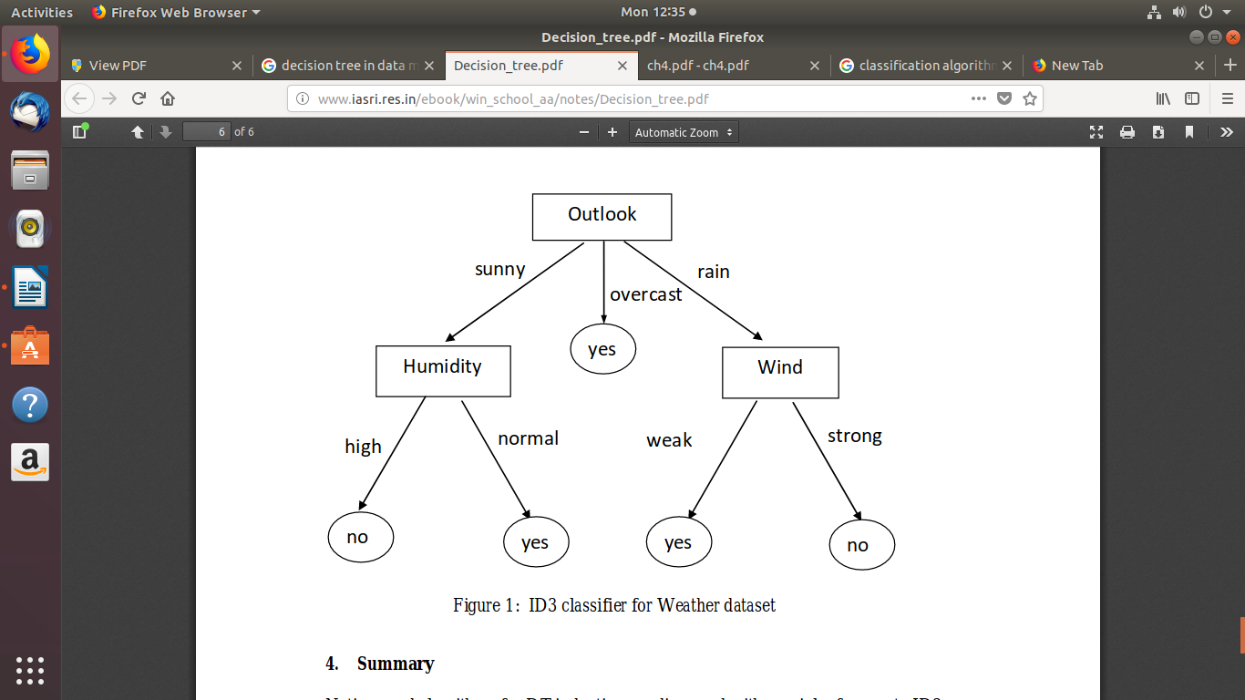

Conclusion-
Notions and algorithms for DT induction are discussed with special reference to ID3 Algorithm. A small hypothetical data set is used to illustrate the concept of decision tree using ID3 algorithm.

